HOW TO REGISTER ON THE SUPPLIER GATEWAY
The Supplier Gateway is the Co-op’s online supplier registration and eSourcing system.

If you are interested in becoming a supplier to the Co-op you can register your interest on the Gateway.

Your details will be held in the system which is accessible by the Buying Team.

If we have a requirement which we think you may be suitable for, and if you meet the necessary criteria, a member of the Buying Team will contact you.
There is a 2 step registration process detailed below

STEP ONE – Initial Registration
- Click on the ‘Register’ tab on the Gateway home page to begin your registration.
- Complete the questions contained in the form and confirm that you have read and accepted the Gateway Terms and Conditions.
- Click ‘Register’ to proceed.
- You will be sent a confirmation email. Click on the link contained in the email to activate your account and set up a password.
- If you haven’t received the system email please check your spam/junk folders. If you haven’t received an email within 5 minutes please contact supplier.gateway@co-operative.coop for help.
STEP TWO – Complete Full Company Profile Questionnaire
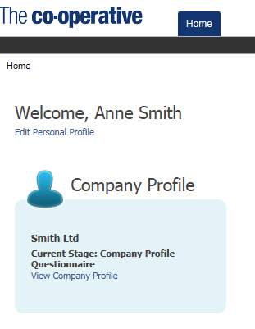  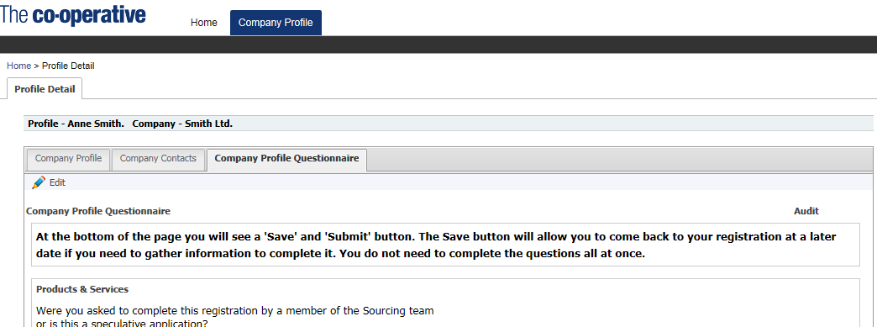 | - Log into the system to complete your full registration. https://www.co-operativeesourcing.coop/  - Click ‘View Company Profile’ to access full question set.  - Click on the ‘Company Profile Questionnaire’ tab  - Click ‘Edit’ icon to go into edit mode and complete the full questionnaire.  - When you are ready click ‘Submit’

